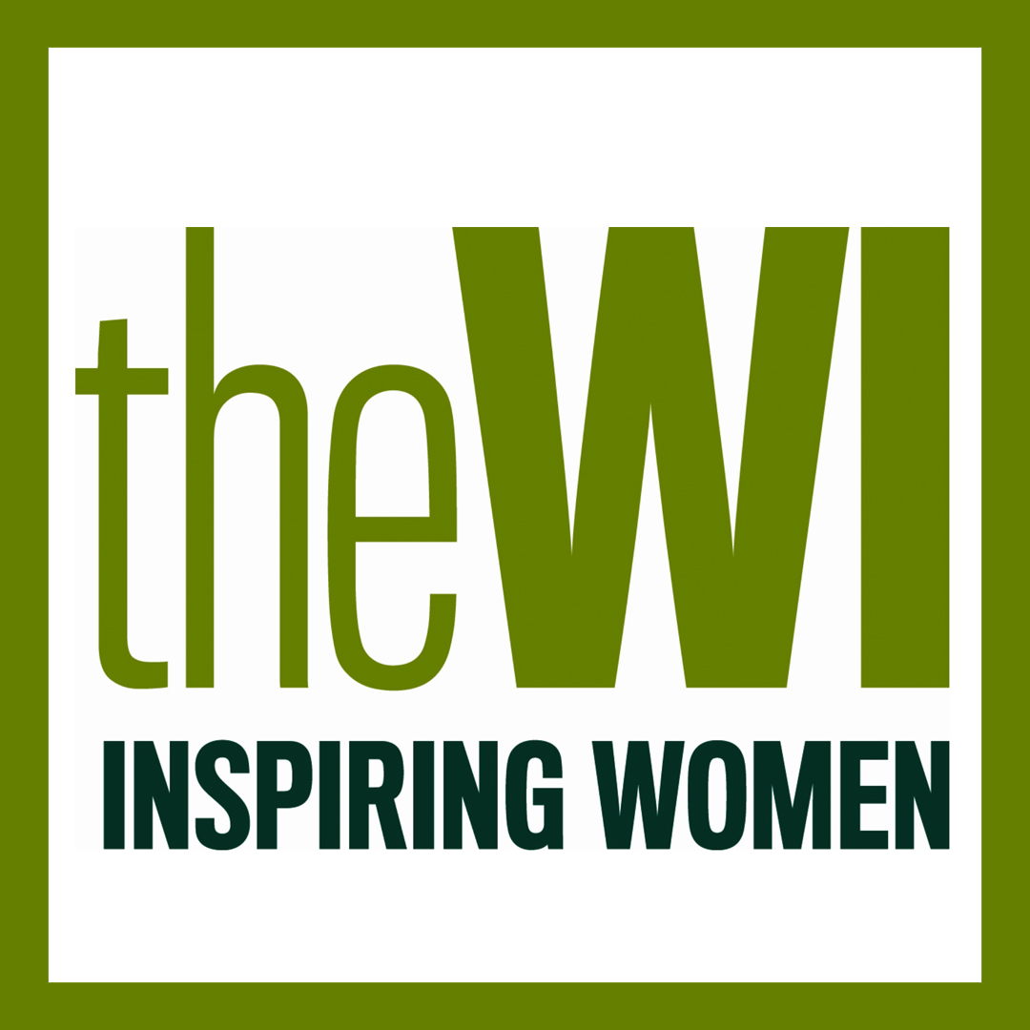

Halam WI
May 2021 Newsletter
New Members to our WI
I would like to introduce our 6 new members to Halam WI:
Sophie Brown
Claire Wright
Vicky Hoad
Sarah Godfrey
Sharon Davidson
Kate Taylor

This means we currently have 23 members. I am really looking forward to welcoming them at our meeting in June.

Programme for the rest of the year
June 8th – Get together for tea and cake at The Milkshed, Radley Rd
July 6th – A treasure hunt round Halam village
August 3rd – Lesley Taylor Talks Rubbish!
September 7th – An introduction to essential oils
October 5th – Bras and breast health
November 2nd – Christmas crafts
December 7th – Christmas party
January 4th – No meeting
February 1st – AGM
Please note these dates are all subject to Covid restrictions being eased and we may have to adjust meetings/activities depending on the rules at the time.

Just a few weeks to go!
Easing of restrictions from 17th May means that up to 30 people can meet outside. Our first meeting since August last year will be at The Milk Company, Radley Road at 7pm on Tuesday 8th June. The seating area has been extended but if you wish to bring your own deck chairs that will enable us to make sure we’re all socially distanced. Drinks can be purchased from the machine in the shed, or you can bring your own. Please let me know if anyone requires a lift that evening.

Sara Subramanian - President

