

Halam WI
October Newsletter
Hello everyone,
This month I have had quite a bit of correspondence from Nottinghamshire Federation and National. Please see the attachments about:
- The proposed closure of Denman College and the sale of the Denman estate.
- Letter about the change to Charitable objects
- The Hornblower
- Virtual Bingo flyer
- ‘Women in Art’ talk via Zoom flyer
- Virtual Christmas Fabric Wreath workshop flyer

Halam Member’s News
We did it!! Last week Lyndsey and I went to Rushcliffe Park to run 5km in aid of the Stroke Association. Despite the rain we in fact managed a total of 6.25km round the park. Thank you to everyone who sponsored us. We raised a total of £310 for the charity.
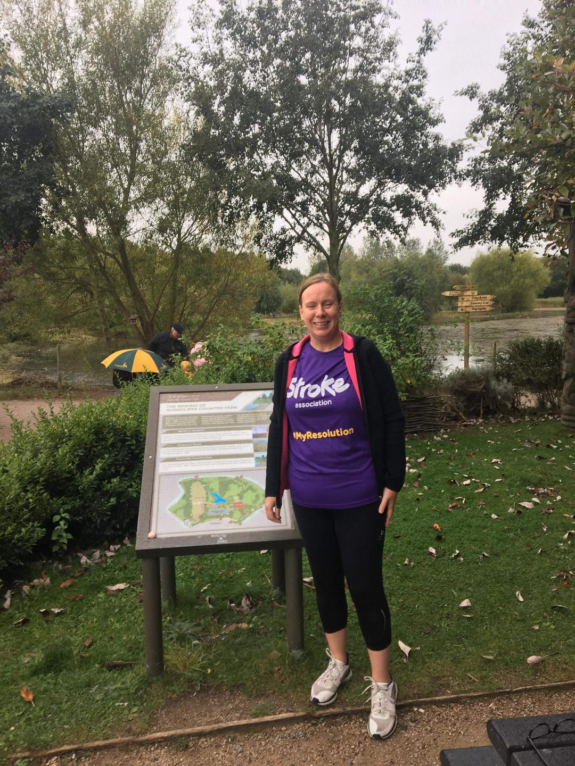
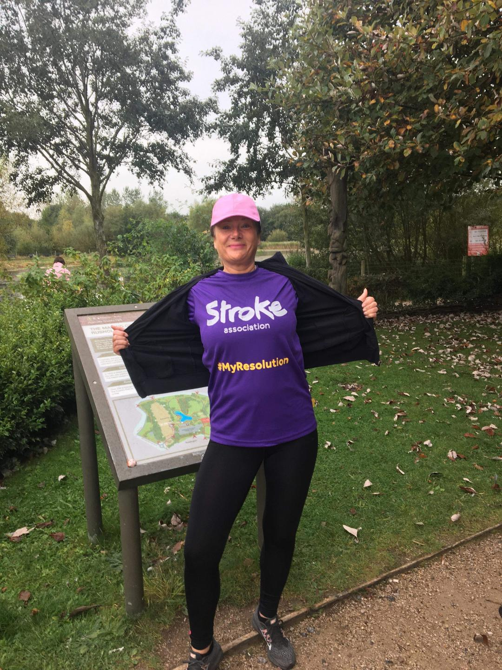

Keep safe and well
Sara

